Types of Graphs in SeaBorn
Seaborn provides several types of graphs for data visualization. Some common types include:

1. Scatter Plot:
python
sns.scatterplot(x='x', y='y', data=data)
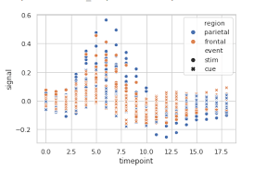

2. Line Plot:
python
sns.lineplot(x='x', y='y', data=data)
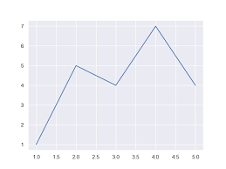

3. Bar Plot:
python
sns.barplot(x='x', y='y', data=data)
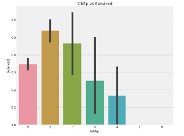

4. Count Plot:
python
sns.countplot(x='category', data=data)
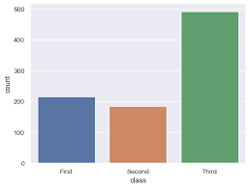

5. Box Plot:
python
sns.boxplot(x='x', y='y', data=data)
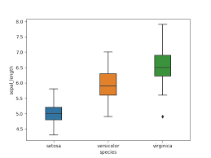

6. Violin Plot:
python
sns.violinplot(x='x', y='y', data=data)
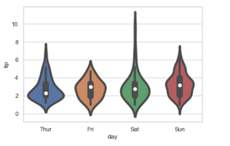

7. Heatmap:
python
sns.heatmap(data.corr(), annot=True, cmap='coolwarm')

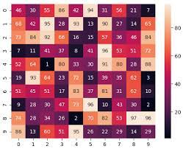
8. Pair Plot:
python
sns.pairplot(data)
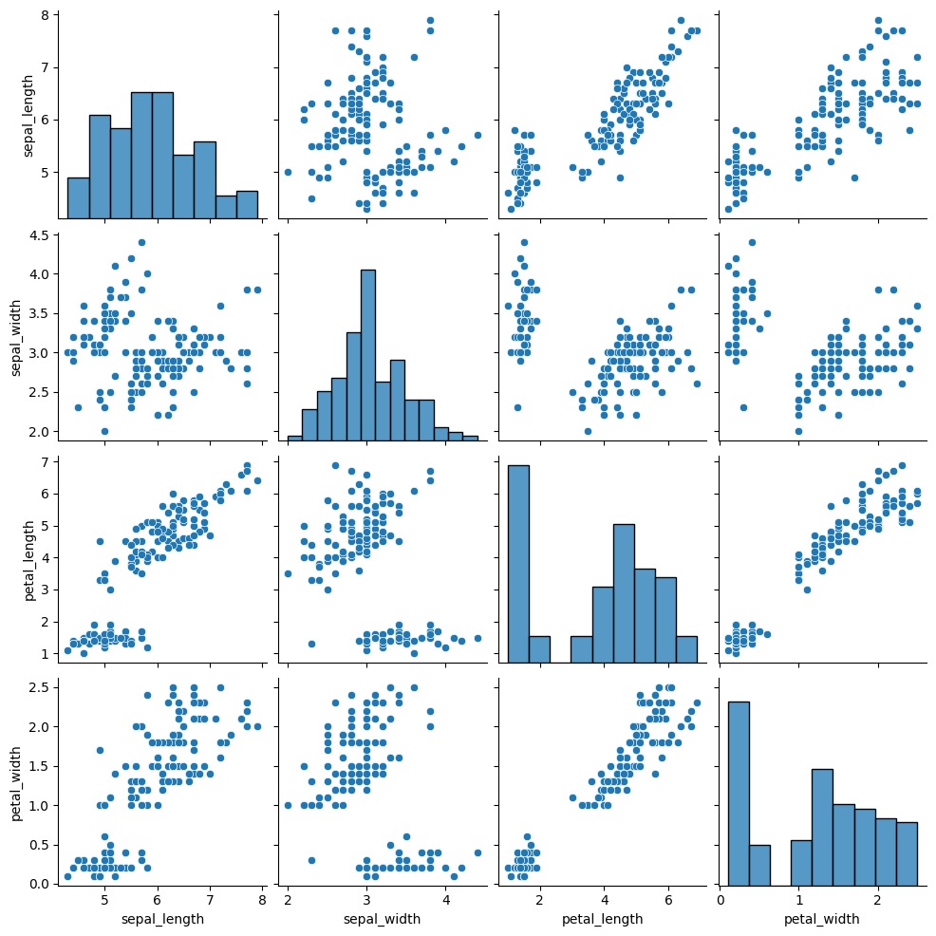

These are just a few examples, and Seaborn offers many more plot types and customization options. Depending on your data and the insights you want to gain, you can choose the appropriate type of plot. Explore the Seaborn documentation for more details and examples: [Seaborn Documentation] (https://seaborn.pydata.org/).

